

**S29F24 | FALL-2024 |**

**Automatic Inventory Management System**

**Abstract:** The **Automatic Inventory Management System (AIMS)** is designed to simplify inventory management and operational tasks for small and medium-sized businesses. It provides an integrated platform that manages sales, purchases, billing, and reporting in one user-friendly system. By automating these processes, AIMS reduces human errors, saves time, and improves overall business efficiency.

AIMS includes AI-powered features that provide intelligent suggestions for better decision-making, such as restocking inventory or optimizing operations. Additionally, the system features an AI chatbot to assist users by answering questions and offering real-time support. These tools help businesses stay ahead by making informed and proactive decisions with minimal effort.

The system is built to be affordable, scalable, and customizable, catering to businesses of various sizes and industries. AIMS not only streamlines day-to-day operations but also promotes long-term growth and success by enabling businesses to focus on innovation and customer satisfaction. With its smart design and practical features, AIMS is a valuable tool for modern business management.

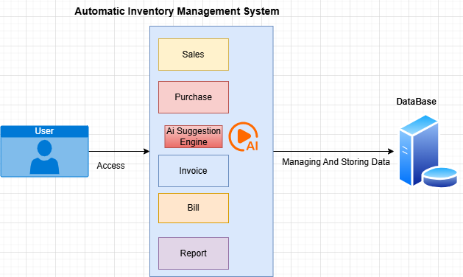

**Figure 1: SYSTEM DIAGRAM**

**Supervisors & Group Members:**

|  |  |  |
| --- | --- | --- |
| **S. No:** | **Name** | **Designation** |
| 1. | Ms.Raazia | Supervisor |
| 2. | Sir Conrad D’Silva | Co-Supervisor |
| 3. | Rimsha Younus cs211237 | Team Lead |
| 4. | Khunsha Noman cs211248 | Member 1 |
| 5. | Summaya Abid cs211240 | Member 2 |
| 6. | Mohammad Mohsin cs211202 | Member 3 |